OWASP TOP 10
TOPICS
- OWASP Top 10 2025: IAAA Failures ⭐⭐⭐⭐⭐

- OWASP Top 10 2025: Application Design Flaws ⭐⭐⭐⭐⭐

- OWASP Top 10 2025: Insecure Data Handling ⭐⭐⭐⭐⭐

Application Design Flaws
application ka design hi insecure ho, chahe code mein bug na ho.

Task 1

Example 1: Client-side Trust (Android)
❌ App khud decide karti hai:
if(user == "admin")
showAdminPanel();
Agar attacker APK modify kar de ya Frida use kare, to admin panel khul sakta hai.
✅ Sahi design:
Server verify kare ke user admin hai ya nah

Example 2: Unlimited OTP Attempts
Password reset:
Enter OTP
App unlimited attempts allow karti hai.
Attacker:
000001
000002
000003
...
999999
Ye design flaw hai. Isme coding error zaroori nahi.
Solution:
- 5 attempts limit
- Account lock
- Rate limiting

Example 3: Business Logic Flaw
Shopping app:
Coupon: 100% OFF
Developer ne check hi nahi ki coupon kitni baar use ho sakta hai.
Attacker coupon baar baar use karta hai.
Ye bhi Application Design Flaw hai.

Example 4: Banking App
App balance dikhati hai.
Transfer request:
POST /transfer

amount=1000
to=Ali
Server check hi nahi karta ke sender ke account mein balance hai ya nahi.
Ye design flaw hai.

Task 2
Security Misconfiguration
Security misconfigurations happen when systems, servers, or applications are deployed with unsafe defaults, incomplete settings, or exposed services. These are not code bugs but mistakes in how the environment, software, or network is set up. They create easy entry points for attackers.

Even small misconfigurations can expose sensitive data, enable privilege escalation, or give attackers a foothold into the system. Modern applications rely on complex stacks, cloud services, and third-party APIs. A single exposed admin panel, an open storage bucket, or misconfigured permissions can compromise the entire system.

Privilege = Permission
Escalation = Badh jana / Increase hona
Privilege Escalation = Apni permissions ko illegally badha lena.

Software Supply Chain Failures

Software Supply Chain kya hoti hai?
Jab developer Android app banata hai, to woh sirf apna code nahi likhta. Woh dusri companies ya open-source projects ke code aur tools bhi use karta hai.
Example:
- Third-party libraries (Retrofit, Glide, OkHttp)
- SDKs (Firebase, Facebook SDK)
- Gradle plugins

Software Supply Chain Failure kya hai?
Jab in dependencies ya tools mein security problem ho aur app un par trust kare, to usse Software Supply Chain Failure kehte hain.
Yani:
App ka apna code secure ho sakta hai, lekin jis library ya tool par app depend karti hai woh insecure ho.

Task 4
Cryptographic failure
Cryptographic failures happen when encryption is used incorrectly or not at all. This includes weak algorithms, hard-coded keys, poor key handling, or unencrypted sensitive data. These flaws let attackers access information that should be private.

Task 5
Insure Design
ab application ki planning ya architecture shuru se hi insecure ho, usay Insecure Design kehte hain.

Simple Example
Suppose ek banking app hai.
Developer ne socha:
User Login
↓
User ID mil gayi
↓
Account Details Show
Ab URL hai:
GET /account?id=1001
User agar ID change kar de:
GET /account?id=1002
Aur dusre user ka account khul jaye.
Yeh coding bug bhi ho sakta hai, lekin agar design hi aisa hai ke sirf ID change karne se access mil jata hai aur ownership check ka concept hi nahi banaya gaya, to yeh Insecure Design hai.

Insecure DATA Handling
Task 1

you will practice exploiting these vulnerabilities:

A04: Cryptographic Failures
A05: Injection
A08: Software or Data integrity Failures

Task 2
cryptographic Failures
What are Cryptographic Failures?
Cryptographic failures happen when sensitive data isn't adequately protected due to lack of encryption, faulty implementation, or insufficient security measures. This includes storing passwords without hashing, using outdated or weak algorithms (such as , SHA1, or ), exposing encryption keys, or failing to secure data during transmission.

Cryptographic Failures Module

Topic | Priority
Breaking Crypto | ⭐⭐⭐⭐⭐
Insecure Randomness | ⭐⭐⭐⭐⭐
ECB Mode | ⭐⭐⭐⭐☆
Padding Oracle | ⭐⭐⭐⭐☆
Length Extension Attack | ⭐⭐☆☆☆
Breaking Crypto the simplest way

Intro
Cryptography is designed to protect sensitive data, but it's only effective when implemented correctly. Even small mistakes in how cryptographic systems are set up can open the door for attackers.

- Prerequisites

Before starting this room, you should have a basic understanding of the following concepts:

- How cryptographic concepts like encryption, decryption, and hashing work.
- Tools like Hashcat or John The Ripper are used to crack passwords and keys.
- HTTP request and response basics, along with some experience using the command line.
- Completion of Cryptography and Cryptography-101 modules.

🔒 Encryption
Definition: Plaintext ko secret (ciphertext) mein convert karna taake unauthorized person usay na padh sake.
- ✅ Reversible (original data wapas mil sakta hai)
- ✅ Key ki zarurat hoti hai
- ✅ Use: Sensitive data protect karna (messages, banking data, files)
Example:
Hello
↓ Encrypt
X7@9#P

🔓 Decryption
Definition: Encrypted data ko correct key ki madad se dobara original form mein lana.
- ✅ Sirf correct key se possible
- ✅ Encryption ka reverse process hai
Example:
X7@9#P
↓ Decrypt
Hello

#️⃣ Hashing
Definition: Data ka unique fingerprint (hash) banana jo reverse nahi kiya ja sakta.
- ❌ Irreversible
- ❌ Original data wapas nahi milta
- ✅ Use: Password verification aur data integrity
Example:
Password: admin123
↓
Hash
↓
240be518...
Login ke waqt password dobara hash hota hai aur stored hash se compare kiya jata hai.
Examples

1. Password Storage (Sabse Common) ✅
Password
↓
Hash
↓
Database
Purpose: Password securely store karna.

2. File Integrity ✅
Check karna ke file change hui hai ya nahi.
Example:
Aap Kali Linux ISO download karti hain.
Website kehti hai:
SHA-256:
A8F3D91...
Aap bhi file ka hash nikalti hain.
Agar dono same hain:
✅ File original hai.
Agar different hain:
❌ File corrupt ya tampered hai.

3. Digital Signatures ✅
Software updates aur APK signing mein hashing use hoti hai.
Android app install karte waqt signature verify hoti hai.

4. Data Integrity ✅
Network par data bhejne ke baad check kiya jata hai ke data change to nahi hua.

5. Git (Version Control) ✅
Git har commit ka unique hash banata hai.
Example:
Commit:
8f3d91ab...
Isi hash se commit identify hoti hai.

If I want to send a msg in encrypted form to my frnd?

Example: GPG (Linux)
Agar aap Kali Linux use kar rahi hain.
Message:
Hello Sara
Encrypt karne ke liye command:
gpg -e -r sara message.txt
Result:
message.txt.gpg
Ye encrypted file hai.
Sara ke paas private key hogi.
Wo decrypt karegi:
gpg -d message.txt.gpg
Output:
Hello Sara

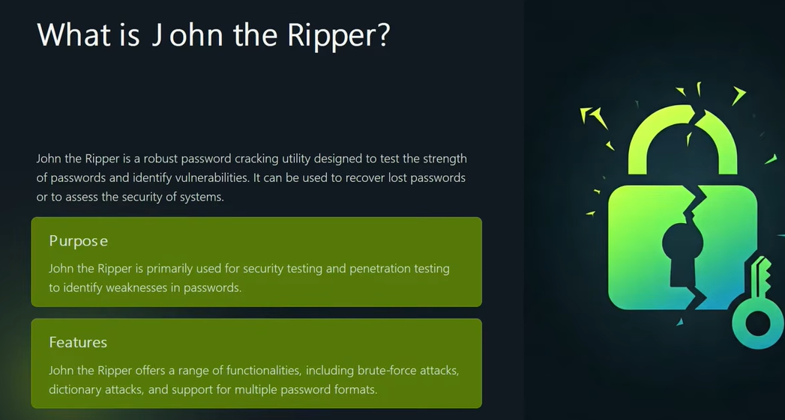

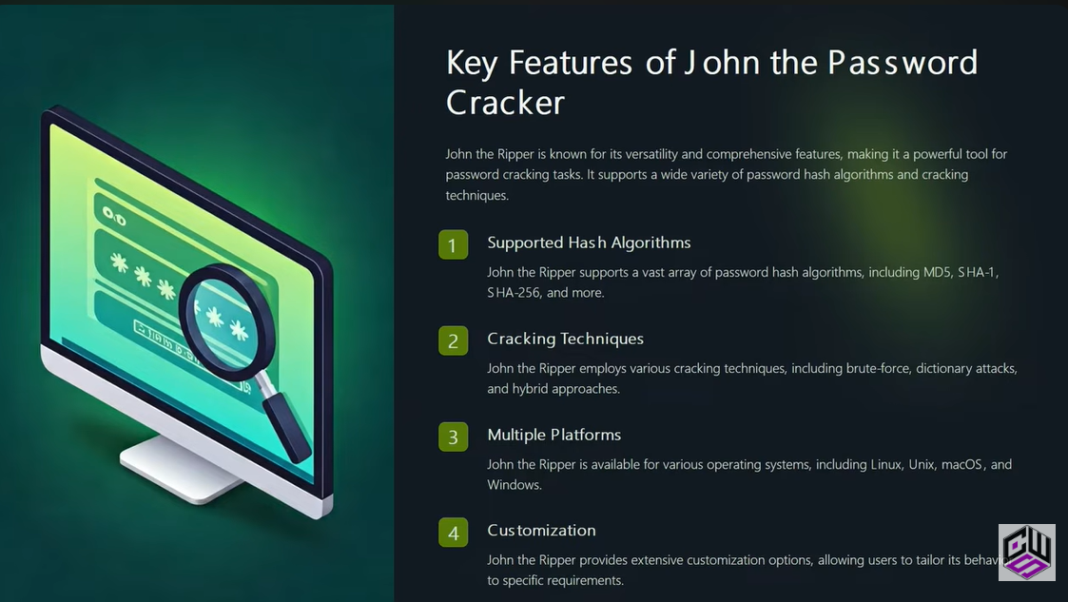

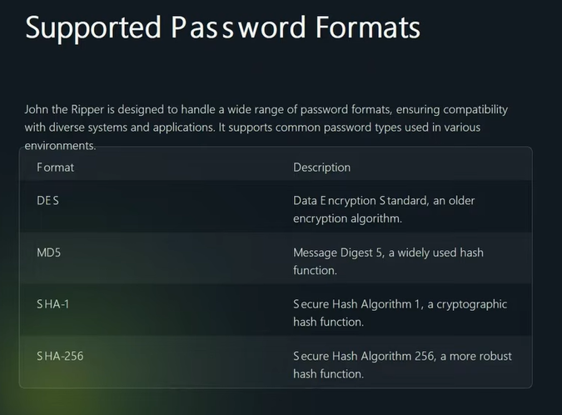

Techniques to crack passwor

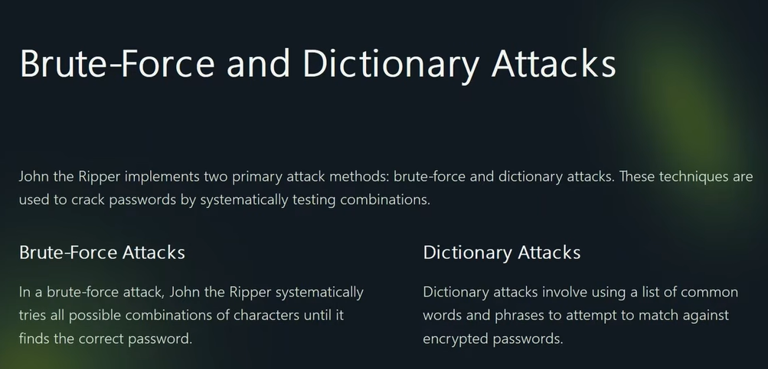

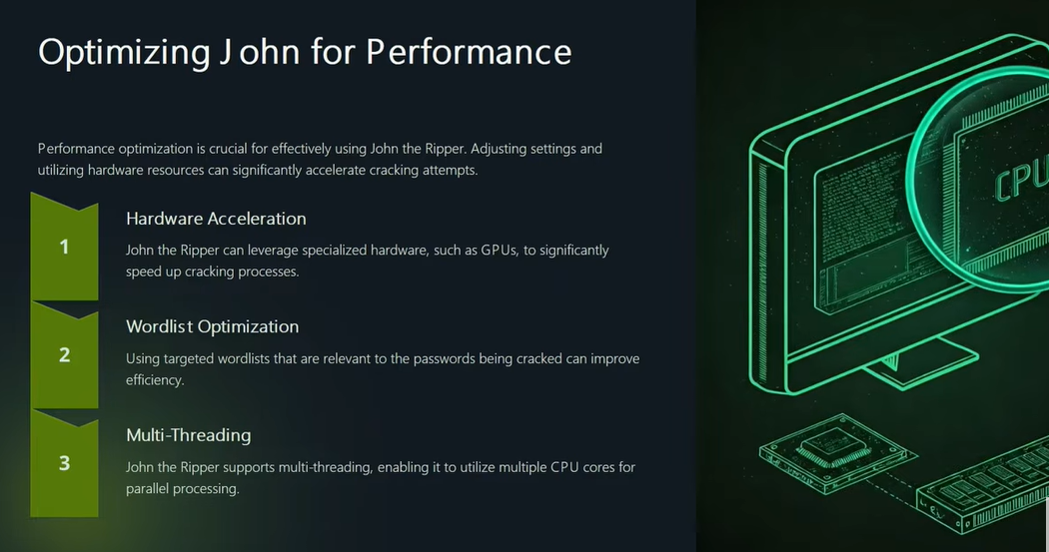

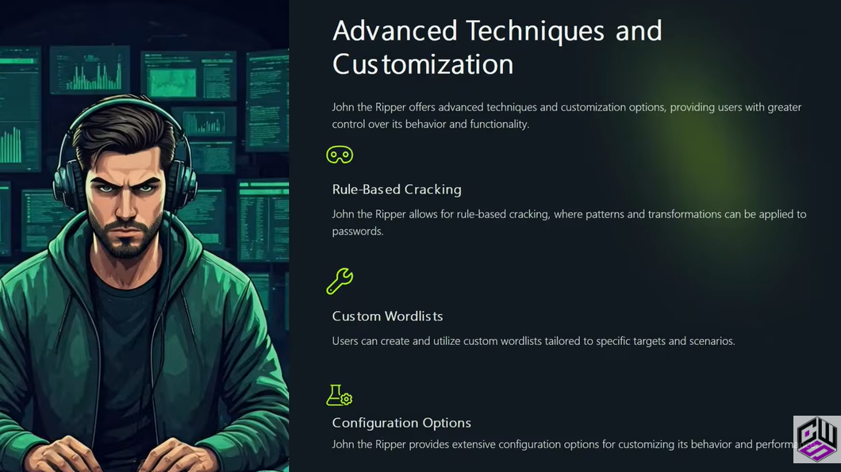

Method to identitfy hash
1st To check type of hash search on google for Hash Analyser you see a various websites for that
John is pre-install in kali but I install it manually from github
2nd A tool Hash id.py is used to identify hash
Install by this command
wget https://gitlab.com/kalilinux/packages/hash-identifier/-/raw/kali/master/hash-id.py
python3 hash-id.py

how to convert the hash to plain text?
Wasy to hash irreverseable hota h but isy crack bhi kr skty hn

To make hashes command is
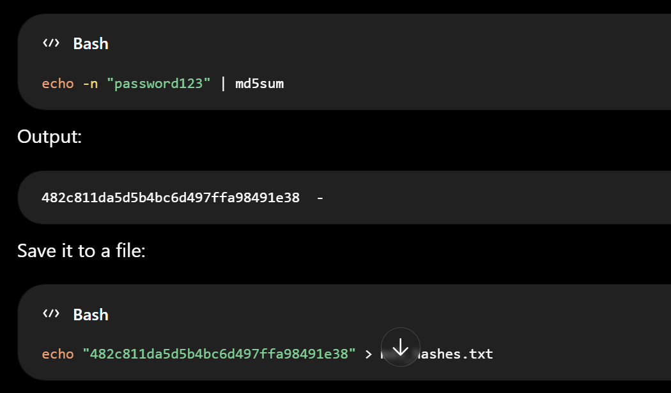

Option 1 (Recommended): Change the ownership
Run:
sudo chown -R kali:kali ~/Desktop/john
Verify:
ls -ld ~/Desktop/john
You should now see something like:
drwxr-xr-x 11 kali kali ...

Step 2: Check who owns the directory
Run:
ls -ld ~/Desktop/john

┌──(kali㉿kali)-[~/Desktop/john]
└─$ pwd
ls -ld .
/home/kali/Desktop/john
drwxr-xr-x 11 root root 4096 Jul 13 11:33 .

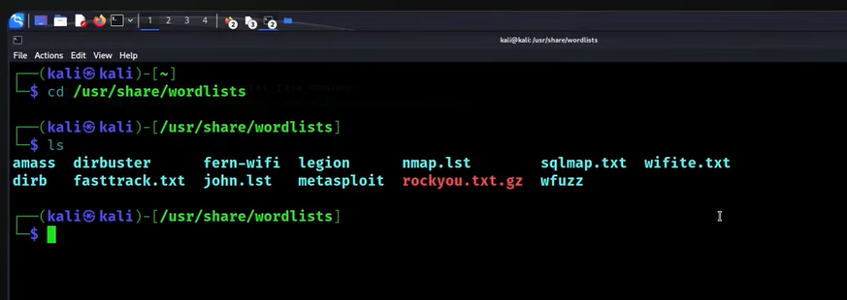

After solving errors we able to crack hash
Sudo john --format=raw-md5 --wordlist=/home/kali/desktop/rockyou.txt hashes.txt

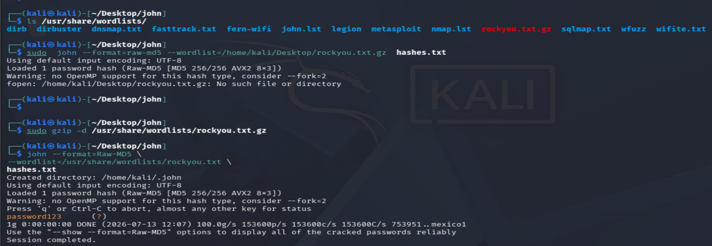

Password successfully crack

Option 1 (Recommended): Decompress rockyou.txt.gz
Run:
sudo gzip -d /usr/share/wordlists/rockyou.txt.gz
Now use:
john --format=Raw-MD5 \
--wordlist=/usr/share/wordlists/rockyou.txt \
hashes.txt

Now we craxk password SHA1
Create a SHA-1 hash
echo -n "password123" | sha1sum

Output:

cbfdac6008f9cab4083784cbd1874f76618d2a97 -
Save it to a file
echo "cbfdac6008f9cab4083784cbd1874f76618d2a97" > sha1.txt

Check it:

cat sha1.txt
If you want to keep both your MD5 and SHA-1 hashes in the hashes folder

Your folder can look like this:

hashes/
├── md5.txt
└── sha1.txt

Create the MD5 file:

echo "482c811da5d5b4bc6d497ffa98491e38" > md5.txt

Create the SHA-1 file:

echo "cbfdac6008f9cab4083784cbd1874f76618d2a97" > sha1.txt

Verify:

ls

Output:

md5.txt
sha1.txt

View the contents:

cat md5.txt
cat sha1.txt
Crack them with John

MD5:

john --format=Raw-MD5 --wordlist=/usr/share/wordlists/rockyou.txt md5.txt

SHA-1:

john --format=Raw-SHA1 --wordlist=/usr/share/wordlists/rockyou.txt sha1.txt

This is a good way to organize your practice files by hash type.

Check it:
cat sha1.txt

command to crack
john --format=Raw-SHA1 \
--wordlist=/usr/share/wordlists/rockyou.txt \
~/Desktop/john/hashes/sha1.txt

Now we are going to crack the windows hash
Windows hash store in ntlm format

To make hash
echo -n "password123" | iconv -t UTF-16LE | openssl dgst -md4

To store file
echo "a9fdfa038c4b75ebc76dc855dd74f0da" > hashes/ntlm.txt

To crack
john --format=NT --wordlist=/usr/share/wordlists/rockyou.txt hashes/ntlm.txt

Now we create linux hash
Modern Linux systems typically use yescrypt or SHA-512 crypt in /etc/shadow.
To gather all info about all account into your system
Sudo cat /etc/passwd

Method 1: Create a SHA-512 crypt hash (good for practice)
Use OpenSSL:
openssl passwd -6 password123
Example output:
$6$N6Y...$y0mX4W...
Save it:
echo '$6$N6Y...$y0mX4W...' > hashes/linux_sha512.txt
Crack it:
john --wordlist=/usr/share/wordlists/rockyou.txt hashes/linux_sha512.txt

if you want to crack

HTTP request and response basics, along with some experience using the command line.
The sentence:
"HTTP request and response basics, along with some experience using the command line."
means these are prerequisites—things you should already know before starting a course or lab.

1. HTTP Request Basics
An HTTP request is sent by a client (browser, mobile app, or tool like curl) to a web server asking for something.
Example:
GET /login HTTP/1.1
Host: example.com
User-Agent: Mozilla/5.0
Parts of a request:
- Method – What you want to do.
  - GET → Read data
  - POST → Send data
  - PUT → Update data
  - DELETE → Delete data
- URL/Path – Which resource you want (/login)
- Headers – Extra information (browser, cookies, authorization)
- Body – Data sent with POST/PUT requests

2. HTTP Response Basics
After receiving the request, the server sends back an HTTP response.
Example:
HTTP/1.1 200 OK
Content-Type: text/html

<html>
Welcome
</html>
Parts of a response:
- Status Code
  - 200 OK → Success
  - 301 → Redirect
  - 403 Forbidden → Access denied
  - 404 Not Found → Page doesn't exist
  - 500 Internal Server Error → Server problem
- Headers
  - Content-Type
  - Content-Length
  - Set-Cookie
  - etc.
- Body
  - HTML
  - JSON
  - Image
  - File
  - etc.

Request and Response Flow
Client (Browser / Mobile App)
|
| HTTP Request
|------------------>
|
Web Server
|
| HTTP Response
|<------------------
|
Client displays the page

3. Command Line Experience
This means you should be comfortable using a terminal (Kali Linux Terminal or Windows Command Prompt).
Some basic commands:
Command | Purpose
pwd | Show current directory
ls | List files
cd | Change directory
mkdir | Create folder
rm | Remove file
cp | Copy file
mv | Move/Rename file
cat | Display file contents
curl | Send HTTP requests
wget | Download files
ping | Check connectivity
nmap | Scan ports
grep | Search text
find | Find files
Example:
curl http://example.com
This sends an HTTP GET request to example.com.
Completion of Cryptography and Cryptography-101 modules.

Cryptography

